|  |
| --- |
|  |
| Restaurant Management Website |
| WE Mini Project |
|  |
|  |
|  |

­­­­

|  |
| --- |
|  |

**Name of Group Members: ­­­**

|  |  |  |
| --- | --- | --- |
| **Roll no.** | **Name** | **Sign** |
| 161 | Pratiksha Sawant |  |
| 163 | Shivangi Saxena |  |
| 165 | Shilpashree Shetty |  |

ABSTRACT

*Online Restaurant Management System (ORMS)* is a web application for restaurant management. This system provides various services and facilities to the customer. The services that are provided are table reservation in advance by the customer online, menu information management, contact forms to report queries directly to the restaurant manager and report. The main objective in building the system is to provide reservation service online to the customer. With this system online, reservation management will become easier and more systematic and replace the traditional system where we are still using paper. Furthermore, this system is can be used anytime and anywhere by the customer.

Software and hardware used in developing this ORMS are Adobe Dreamweaver 8, Adobe Photoshop CS5, JavaScript and TextPad. The website will act as an efficient and interactive channel for communicating with customers and can also be used to advertise certain services and products.

ACKNOWLEDGEMENTS

I would like to take this opportunity to express my gratitude to all those who gave me the opportunity to complete this project.

I am most deeply indebted to **Mr Jayendra Jadhav**, without whose guidance this project could not have been completed.

I also wish to thank **Mr Anil Z. Chhangani**, the *Head of the Department* for granting me with the required permissions to do the necessary research work and also to use departmental resources.

I appreciate all the help and cooperation given by the *Department of Computer Science* of *Lokmanya Tilak College of Engineering* for being without which this project would have remained incomplete.

TABLE OF CONTENTS

|  |  |
| --- | --- |
| **TOPIC** | PAGE NO. |
| Abstract | i |
| Acknowledgements | ii |
| Table of Figures | iv |
| 1. Introduction    1. Project Background    2. Objective    3. Scope    4. Applicability    5. Organization of Report | 1  1  1  1  2  2 |
| 1. Survey of technologies | 3 |
| 1. Requirements    1. Software Requirements    2. Hardware Requirements | 5  5  6 |
| 1. System Description    1. Use Case Diagram    2. Working of the System | 7  7  9 |
| 1. Conclusion & Future Work    1. Conclusion    2. Limitations of the System    3. Future Scope of Project | 21  21  21  21 |
| References | 22 |

TABLE OF FIGURES

Figure 1: Use Case Diagram 8

Figure 2: Header 10

Figure 3: Navigation Bar 10

Figure 4: Navigation Bar With Hover 10

Figure 5: Home Page 1 11

Figure 6: Home Page 2 11

Figure 7: Menu Page With Hover 12

Figure 8: Beverages Page 12

Figure 9: Image Lightbox 13

Figure 10: About Us Page 14

Figure 11: Location Page 14

Figure 12: Book-A-Table Page 1 15

Figure 13: Book-A-Table Page 2 15

Figure 14: Catering Page 1 16

Figure 15: Catering Page 2 16

Figure 16: Contact Us Page 1 17

Figure 17: Contact Us Page 2 17

1. INTRODUCTION
   1. **PROJECT BACKGROUND**

ZEST-Restaurant Website is a website for managing the restaurant business. The main point of developing this website is to provide online menu information and help customer for reserving table.  If customers are willing to book, they may visit the website to check out the services the restaurant offers, what type of food it serves as well as the catering services. They may also need to know the actual location and require the directions to get there. Thus we can effectively say that this website is an online brochure that is available to everyone in the world. The website will help the restaurant administrator to manage the restaurant and will provide customer ease. Other than that, this project is to upgrade the manual system and make the business easy to access and systematic. Websites are also a convenient tool for marketing.

* 1. **OBJECTIVE**

The Objectives of ZEST are:

* To provide online menu information for customer
* To provide an online facility for booking a table. In previous system (i.e. manual system), person had to go to the restaurant for booking a table, enquiry etc. This was time consuming and expensive. Through this product, person can book the table by sitting in the comforts of their own house.
* To develop user interface for online restaurant management system.
  1. **SCOPE**

There may be many sites similar to our site but Zest is easy to use and provide services like table booking, feedback on various enquiries such as catering, job as well as general enquiry, information about the menu and also helps to locate ZEST. The site is user-friendly and communicates authenticity and freshness. The menu is noteworthy: simple to browse and very clean.

* 1. **APPLICABILITY**

This project is applicable in the hospitality industry. The hospitality industry in the current global market is ever growing hence a site like "ZEST" has a vast applicability in not only the hospitality industry but in the catering industry also the site provides a wide variety of food and drinks to choose from with the options to book a table on the go and also fulfils your catering need. The Versatile nature of this site makes it applicable in this industry.

* 1. **ORGANIZATION**

*Chapter 2* consists of a survey of all the technologies used and contains all the list of software and coding languages used to create this website and all the functionalities of the website to make it interactive.

*Chapter 3* lists all the requirements, both software and hardware related, and discusses about the minimum software and hardware requirements that are necessary to run the website in a desktop/laptop.

*Chapter 4* gives the system description. This chapter is sub-divided into two parts:

1. **Use Case Diagram:** Describes the visualization, specification, construction, and documentation of the (intended) behaviour of the system, during requirements capture and analysis.
2. **Working of the System** consists of a series of screenshots which pictorially describes the working of the entire system.

*Chapter 5* is the last and final chapter. It is divided into 3 parts:

1. **Conclusion:** Will conclude the project throwing light on the final chapter.
2. **Limitations of the System:** Discusses the drawbacks of this project and their solution.
3. **Future Scope of the Project:** Explains any upcoming improvement of the project.
4. SURVEY OF TECHNOLOGIES

Several technologies were used while developing this project. These include:

1. **HTML**

HTML stands for HyperText Markup Language. It allows all types of computers to interpret information on the World Wide Web (WWW) in the same way. HTML is a series of tags. HTML codes can be written in upper or lower case, are enclosed in brackets “<>”, and sometimes occur in pairs that surround text you are coding for special treatment much like parentheses or quotation marks. The ending tag differs from the beginning tag: it contains a / (forward slash as the first character within the brackets) to signify the closing of the tag.

HTML is a versatile language and can be used on any windows or other platform. HTML elements form the building blocks of all websites. HTML allows images and objects to be embedded and can be used to create interactive forms. It provides a means to create structured documents by denoting structural semantics for text such as headings, paragraphs, lists, links, quotes and other items. It can embed scripts in languages such as JavaScript which affect the behaviour of HTML webpages.

HTML markup consists of several key components, including elements (and their attributes), character-based data types, character references and entity references. Another important component is the document type declaration, which triggers standards mode rendering.

1. **CSS**

Cascading style sheets (or CSS for short) takes control of the style of your pages, including the colours and size of fonts, the width and colours of lines, and the amount of space between items on the page. The cascading style sheets specification works by allowing you to specify rules that say how the content of elements within your document should appear. For example, you can specify that the background of the page is a cream colour, the contents of all < p > elements should be displayed in grey using the Arial typeface, and that all < h1 > elements should be in red using the Times New Roman typeface.

1. **JavaScript**

Java Script is a programming language for small routine and applications, and developed to serve a particular purpose. Scripting languages are usually interpreted rather than compiled. Programs written interpreted languages must be translated into machine code every time they are run, they are typically slower than compiled programs.

Being interpreted does have its advantages. One is platform independence. Because an interpreter performs the translation, you can write your program once and run it on a variety of platforms. In the case of JavaScript, the interpreter is built into Web Browsers. Browsers are available for a variety of platforms and operating systems. Another advantage is that scripting languages are often loosely typed and more forgiving then compiled languages.

As a scripting language, JavaScript is easy to learn and easy to use. You can embed command directly into your HTML code and the browser will interpret and run them at the appropriate time. JavaScript is loosely typed. You don't have to declare the type of data that will be stored in available before you use it.

1. **Adobe Photoshop CS5**

Adobe Photoshop is a professional image editing software package that can be used by experts and novices alike. This software is extremely handy when creating images for buttons and logos of the website.

1. **Adobe Dreamweaver**

Adobe Dreamweaver is a proprietary web development application originally created by Macromedia providing both visual and code-level capabilities to create and maintain standards-based websites and applications for desktops, smartphones, and tablets. Enhanced features help streamline your design and development workflow, build adaptive page layouts, and deliver content from one source to virtually any screens or devices. Dreamweaver can also be used as a text editor.

1. REQUIREMENTS
   1. **Software Requirements**

The main features of Software Requirement Specification (SRS) include:

* + - Establishing the basis for an agreement between the client and the developer.
    - Producing a reference for validation of the final product. SRS assist clients in determining if the software meets the requirements.

Mainly there are six requirements which an SRS must satisfy:

1. It should specify the external behaviour.
2. It should specify the constraints.
3. It should be easy to change.
4. It should be a reference tool.
5. It should record throughout the lifecycle.
6. It should have the capacity of expectation of an undesired event.

Usually we come across three types of requirement specification:

1. User Interface Requirements
2. Functional Requirements
3. Non-Functional Requirements
4. **User Interface Requirements**

The user of the proposed system requires that the developed software should be user friendly, have security access, and ensure the privacy of the administrator and produce results in timely manner. The users are not frequently exposed to the on-line restaurant management, so the system interface to the user must be simple and understandable. The web pages must be user-friendly and must be in an easy-to-use style. The user must be able to easily switch among various tabs. The product should be well designed so that it can be used easily by the users who are novices to the system. A user-friendly interface must be provided so that the user can easily interact with the system and comprehend things in a quicker and easier way. The system must provide reliable and up-to- date information. The application should be efficient so that the user does not spend much time in training. Consistency will increase the confidence of the user in the reliability of the application. The user must be limited with a small set of operations to achieve the result. The application should be visually and conceptually clear. The interface should accommodate user mistakes easily and fast.

1. **Functional Requirements**

The various functional requirements of the system can be summarized as:-

* + - A home page that is user friendly and ambiguous.
    - Easy Table Reservation Process
    - Provide Reservation Confirmation
    - Links to all categories of menu.
    - Ability of Administrator to perform any tasks.

1. **Non-Functional Requirements**

Non-functional requirements define the system properties and constraints that arise through user needs, because of the budgeted constraints or organizational policies, or because of the need for interoperability with other software or due to the external factors such as safety regulations privacy registrations and so on.

* 1. **Hardware Requirements**

The website requires a minimum specification of:

* Pentium 4 processor
* 128 MB RAM
* Adequate internet speed

1. SYSTEM DESCRIPTION
   1. **Use Case Diagram**

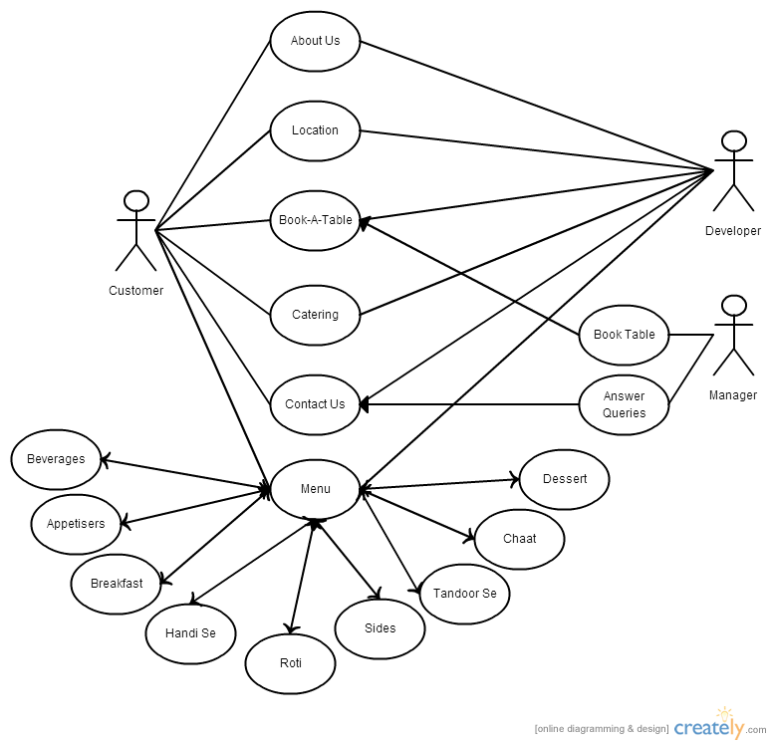

*Figure 1: Use Case Diagram*

The use case diagram shows a list of steps and defines interactions between the "actor" and the system, to achieve a goal. The actors involved in the system are:

* + - **Customer**

The customer will be the user towards which the website will be aimed. The customer can gather information about the restaurant from the site. This information includes the menu, location and catering services of the restaurant.

Customers are also allowed to book tables in advance and even give preference to which table they would like to be seated at. A contact form is provided to the customer in case of any queries.

* + - **Developer**

The developer is the user that has access to the entire site. He has the responsibility to not only create the site but to also keep it up-to-date. Any changes that need to be made are reported to the developer, who then works on implementing them. The developer is thus responsible for the looks as well as content of the site.

* + - **Manager**

The manager is the Restaurant Manager whose work involves booking tables specified by the customer for given dates and also answering queries received through the ‘contact us’ form.

* 1. **Working of the System**

The header of the website is as follows:

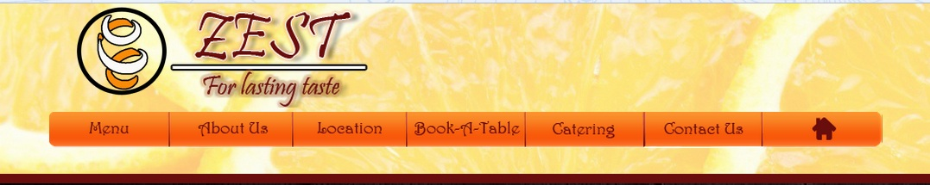

*Figure 2: Header*

The logo and name of the restaurant are both links to the home page.

The navigation bar uses CSS sprites to add button images for each page. By using CSS sprites, a single image can be used for all buttons, instead of having multiple images to load. Since a web page with multiple images may take a long time to load, image sprites are useful in reducing the number of server requests as well as saving bandwidth.

In this case, the below image is used as a sprite through which we can get 14 different images for all buttons- 7 buttons in *normal* state and 7 in *hover*.



*Figure 3: Navigation Bar*

The result of using different images for hover is as follows:

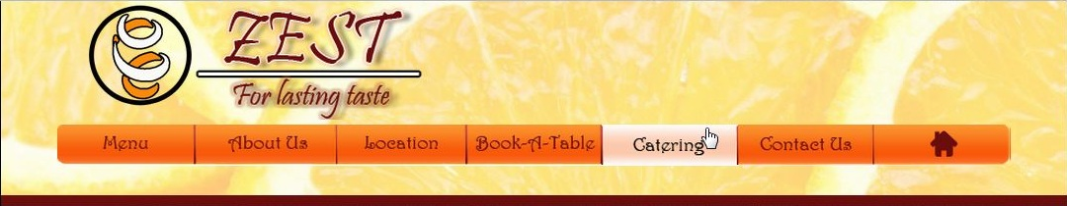

*Figure 4: Navigation bar with hover*

The layout of the site is designed with the help of *div* tag.

The flow of activity on the website can be described in terms of the following pages:

* **Home page**

The homepage consists of a small introduction to the website along with pictures of food offered in the menu. These pictures are shown with the help of iframes. Iframes are used to display webpages or images within a webpage. The users are shown small thumbnails on the left which when clicked-on are displayed on the right with captions.

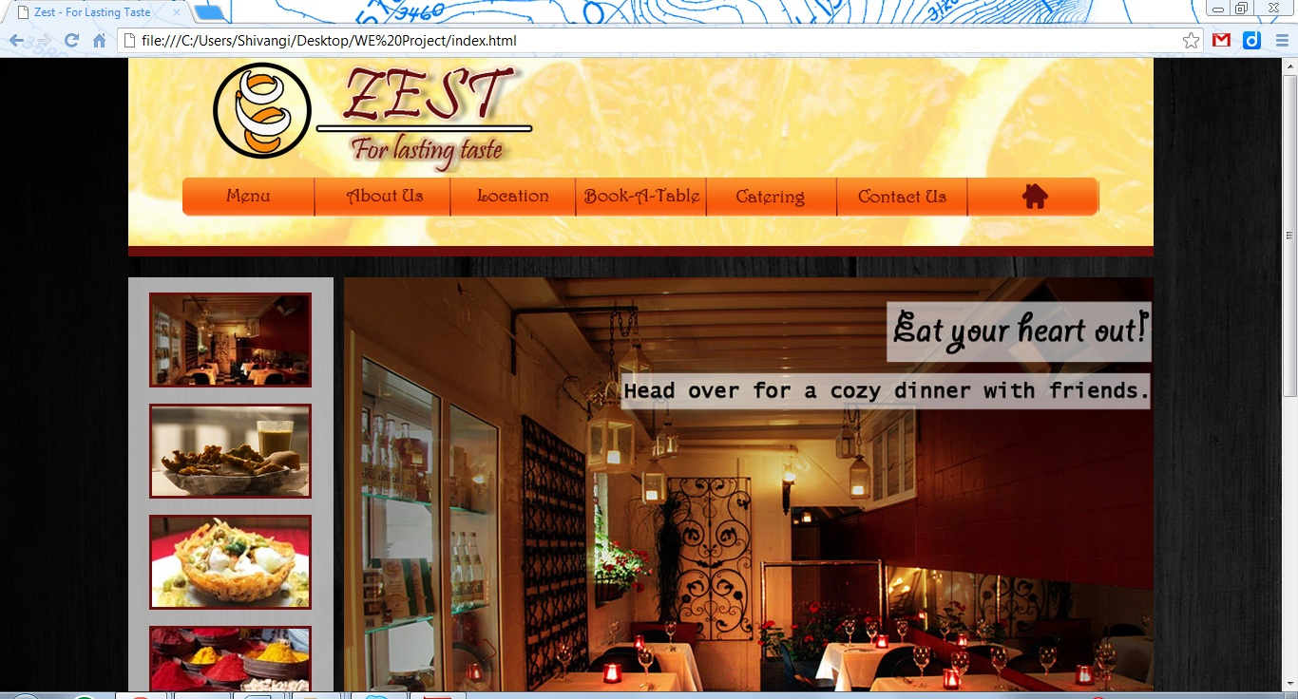

*Figure 5: Home Page 1*

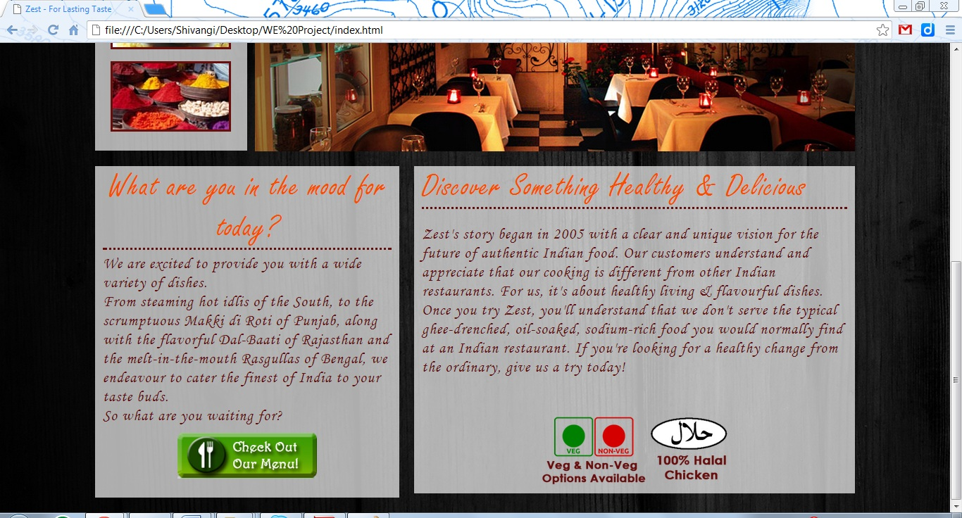

*Figure 6: Home Page 2*

* **Menu**

The menu page has several buttons which lead to different categories of the menu. These include beverages, appetisers, desserts etc. the user is shown a small thumbnail by default, which on hover changes to the name of the category.

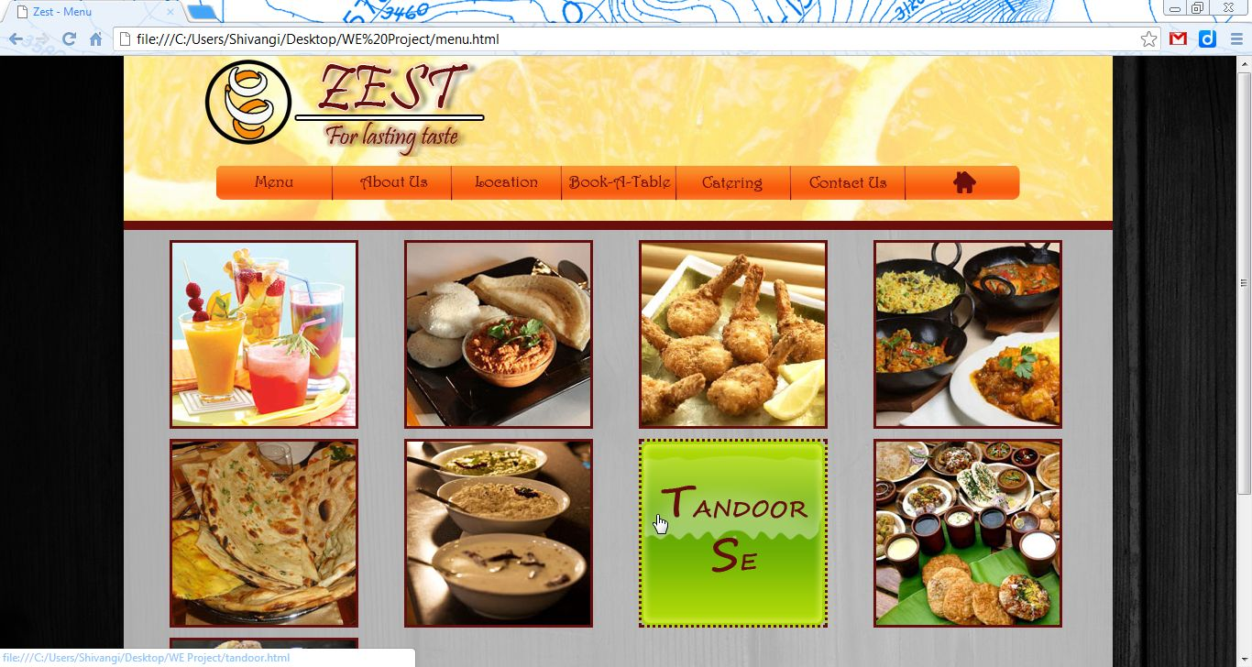

*Figure 7: Menu Page with hover*

Each page inside the menu has a link which comes back to the main menu page.

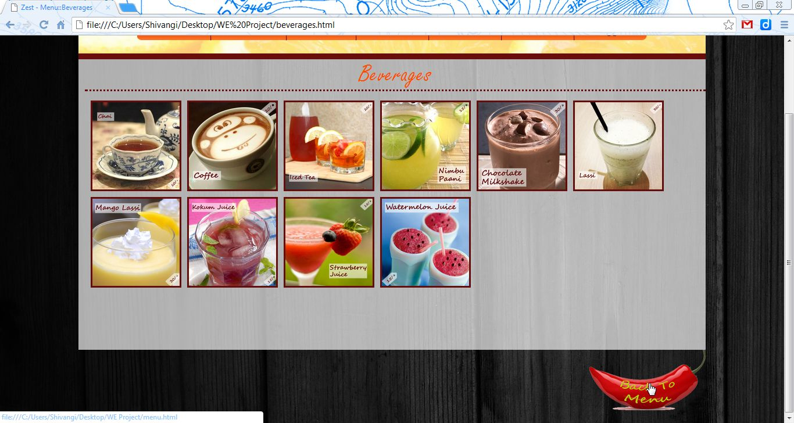

*Figure 8: Beverages Page*

On clicking on any of the images in the menu, the image opens up in a lightbox, i.e. the background fades to dark and the image appears enlarged.

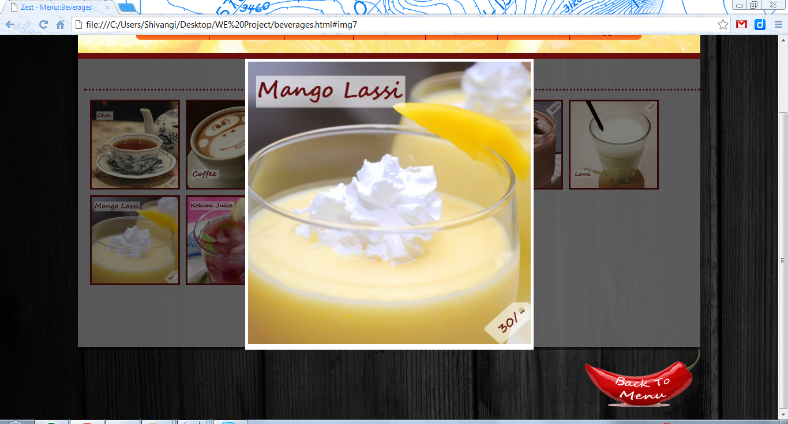

*Figure 9: Image Lightbox*

* **About Us**

This page is a static document-centric page, which only provides information to the user and has no dynamic interaction. The About Us page introduces the restaurant to the user and sums up a small bit of the history of the organization.

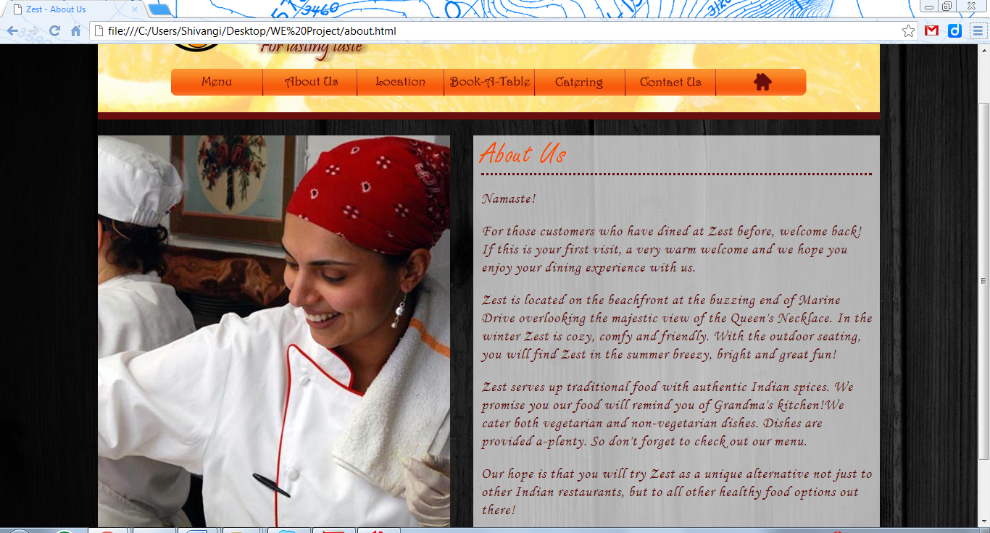

*Figure 10: About Us page*

* **Location**

Customers would want to find out the exact address of the restaurant. This is done not just by giving the address of the restaurant but also by showing the location on Google maps which is achieved by using *iframes*.

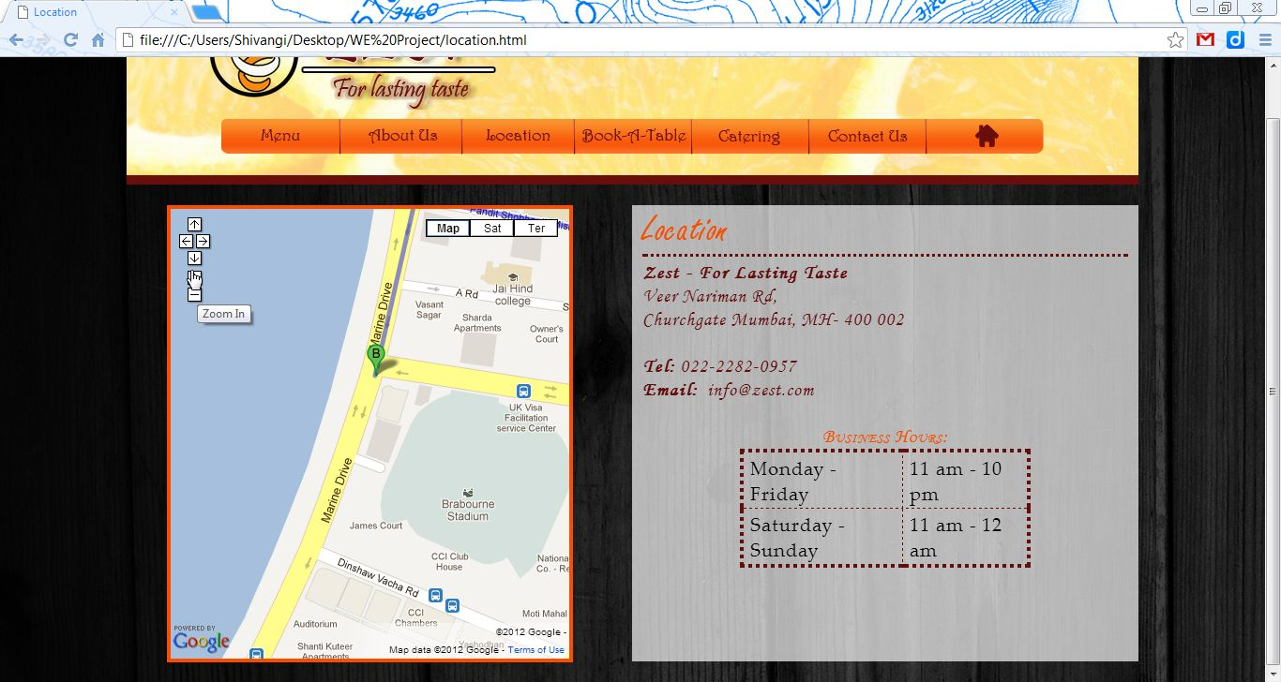

*Figure 11: Location Page*

* **Book-A-Table**

Customers are allowed to book tables at the restaurant in advance through the Book-A-Table page. They are required to enter date and time of the reservation in a form and can choose their seating.

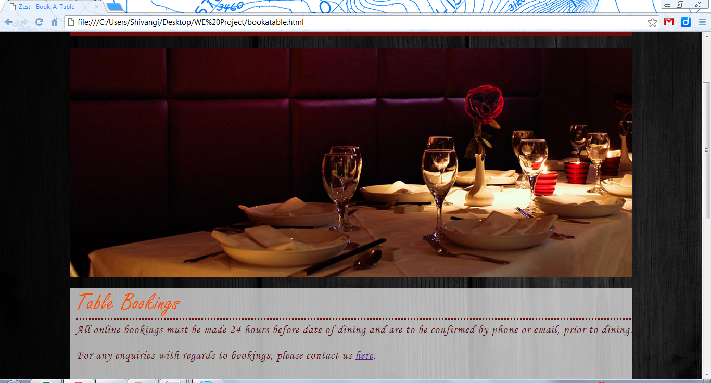

*Figure 12: Book-A-Table page 1*

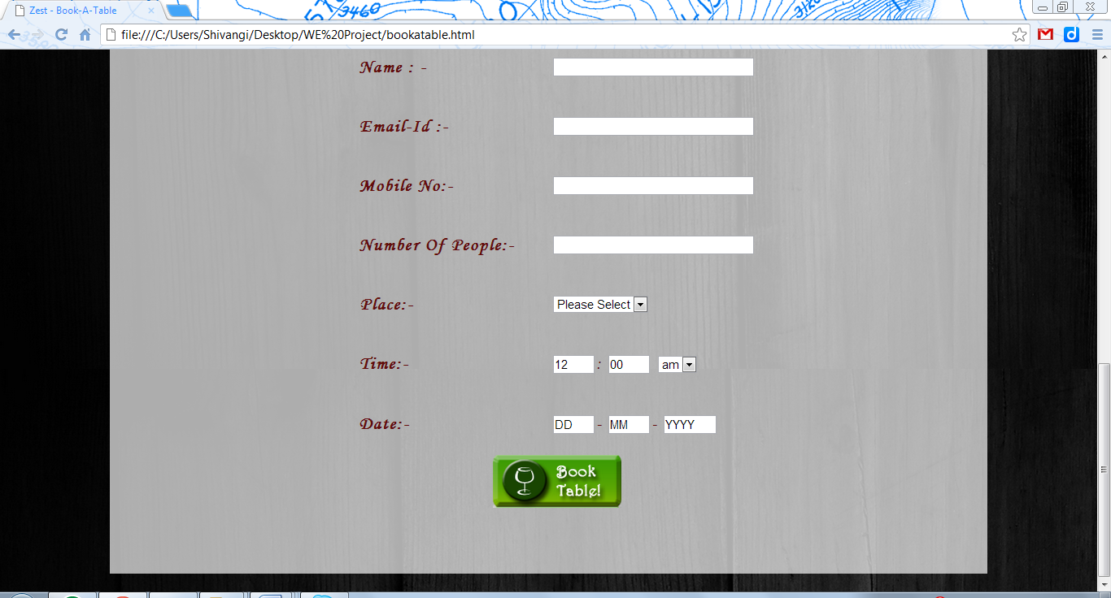

*Figure 13: Book-A-Table page 2*

* **Catering**

Catering is also a static page which provides information about the catering services offered by the restaurant. It specifies the menu along with rates and veg/non-veg options.

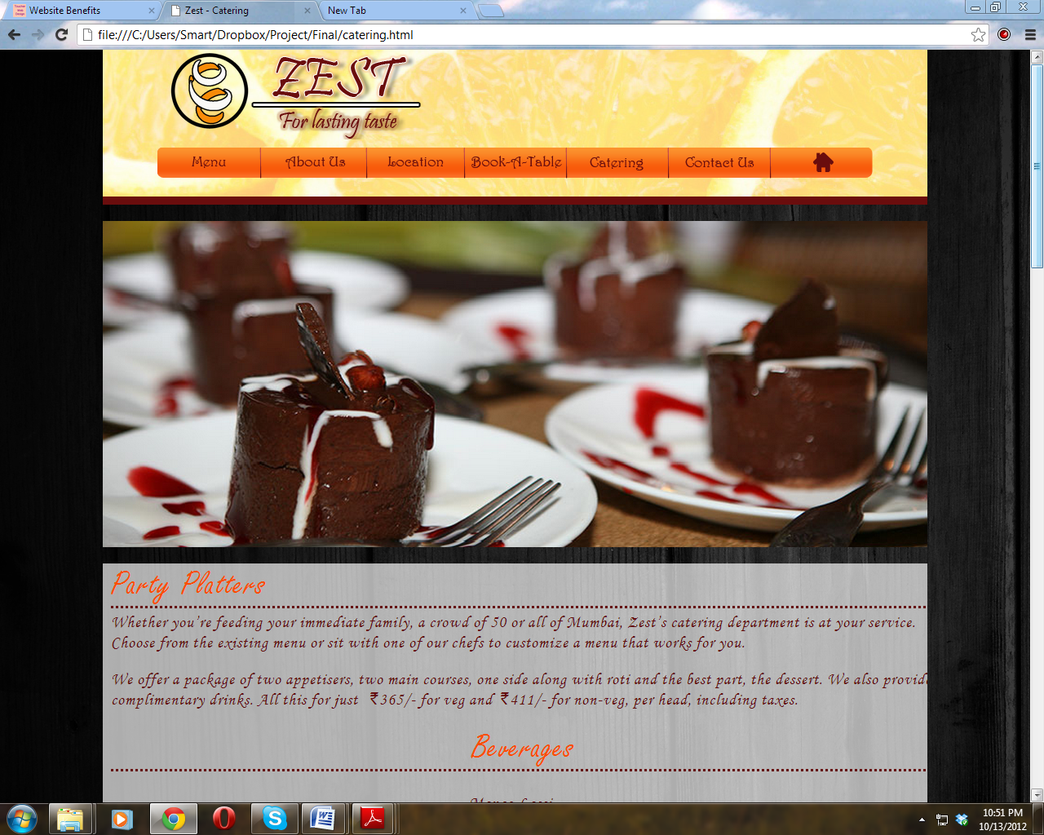

*Figure 14: Catering Page 1*

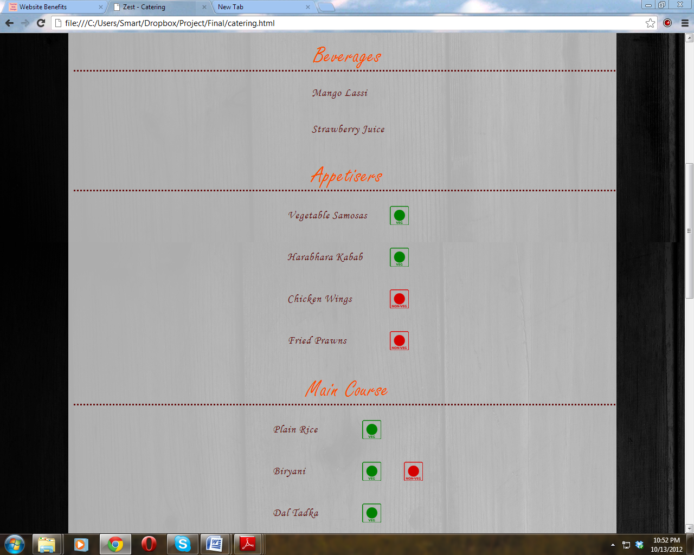

*Figure 15: Catering page 2*

* **Contact Us**

The Contact Us page has form which needs to be filled in by the customer in case of any enquiries and/or questions. Proper validation has been added to the form so that name and email fields are mandatory.

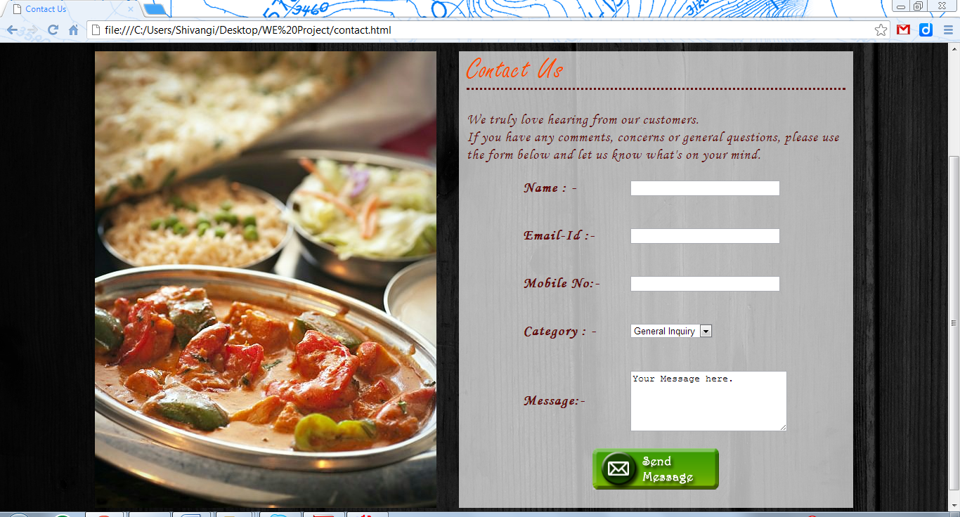

*Figure 16: Contact Us Page 1*

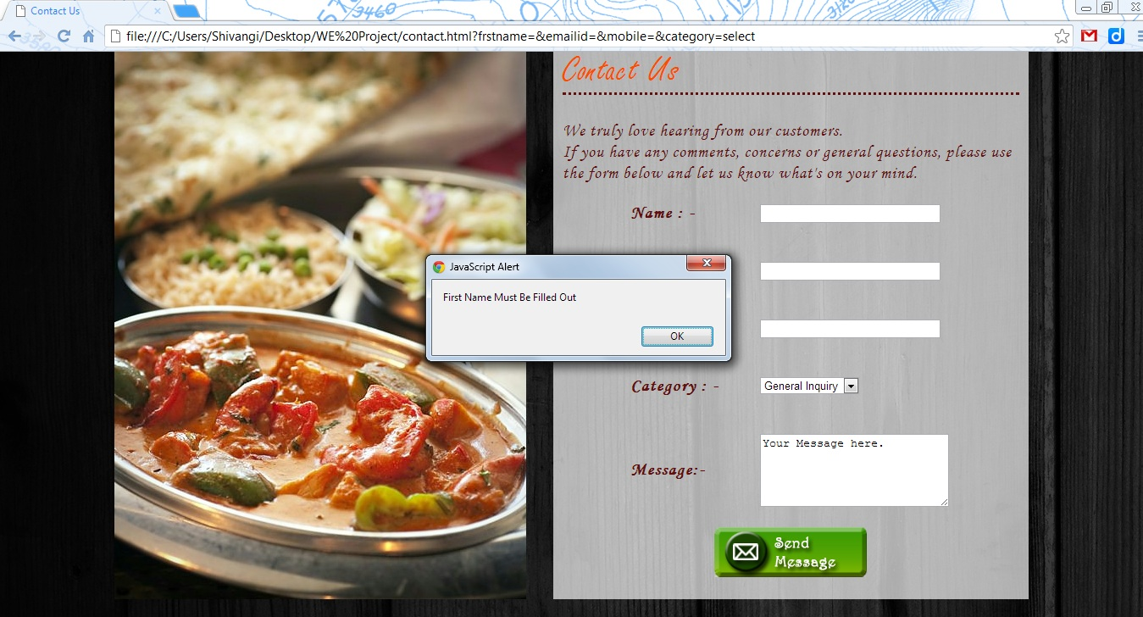

*Figure 17: Contact Us Page 2*

1. CONCLUSIONS AND FUTURE WORK
   1. **Conclusion**

From a proper analysis of positive points and constraints on the component, it can be safely concluded that the product is a highly efficient GUI based component. This application is working properly and meeting to all user requirements. This component can be easily plugged in many other systems. Chapter I described each problem occurred by using the manual system. Project objective and project scope identified the solution for each of the problem.

This project is designed to meet the requirements of Online Restaurant Management. It has been developed in HTML, CSS and JavaScript keeping in mind the specifications of the system. For designing the system we have used simple use case diagrams. Overall the project teaches us essential skills like:

* Using system analysis and design techniques like use case diagram in designing the system.
* Understanding the database handling and query processing.
  1. **Limitations of the System**

Nowadays restaurants are providing many other facilities. This project can also be improved with these improvements in the restaurants. Utmost care and back-up procedures must be established to ensure 100% successful implementation of the computerized restaurant management system. In case of system failure, the organization should be in a position to process the transaction with another organization or if the worst comes to the worst, it should be in a position to complete it manually.

* 1. **Future Scope of the Project**

This project can be used in the restaurant after adding some more useful modules for which restaurant are providing services. Online ordering of food can be added as an additional service for the customers.

REFERENCES

http://lavistanz.co.nz/gallery/

http://www.puratanrestaurant.com/start-restaurant-slideshow.html

http://www.lomahousevegexpress.com/

http://www.vedatakeout.com/

http://www.thelondonfoodie.co.uk/2011/08/london-restaurant-reviews-malabar.html

http://www.paper-leaf.com/portfolio/loma-house-restaurant/